Cheltenham celebrates International Women’s Day with lots of pride and no prejudice!
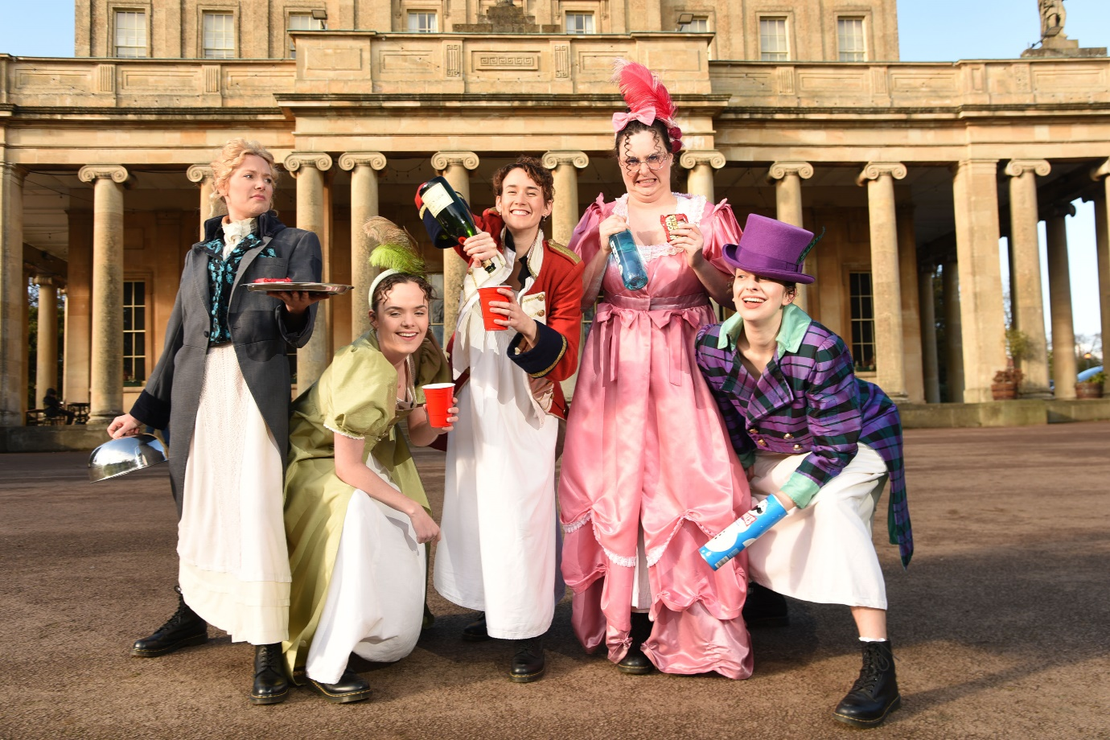
Pride and Prejudice* (*sort of), Cast, Pittville Pump Room, Cheltenham
Left to right – Dannie Harris, Ruth Brotherton, Megan Louise Wilson, Leah Jamieson and Lucy Gray.
As the world celebrates International Women’s Day, the local theatre and arts scene in Cheltenham is gearing up for a unique celebration of women’s creativity and talent. The Laurence Olivier award-winning comedy Pride and Prejudice* (*sort of), arrives on the main stage at the Everyman Theatre, Cheltenham.
Pittville Pump Room provided the perfect regency backdrop, mirroring that of the original Pride and Prejudice tale, for Cheltenham’s period celebration of International Women’s Day. Pride and Prejudice* (*sort of) is a witty and irreverant retelling of Jane Austen’s most iconic love story, written by the Evening Standard’s 2022 Emerging Talent award winner, Isobel McArthur, and performed in full by a five-strong all-female cast, who even dare to take on the dashing roles of Mr Darcy, Mr Bennet and George Wickham alongside the leading female roles. The play has thus far earned rave reviews from critics and audiences alike.

To mark this key date in the international events diary, The Everyman and The Cheltenham Trust joined forces as two of the leading champions of arts, heritage and culture in the town. The cast (pictured here) marched to the Grade 1 listed architectural gem in Pittville Park in full costume to take in the regency sights, before heading off to star in the unique and audacious retelling of Jane Austen’s most beloved novel.
International Women's Day, also known as IWD for short, grew out of the labour movement to become an annual event recognised by the United Nations. The event aims to encourage everyone to challenge gender bias and inequality, celebrate women's achievements, and support their advancement in all fields, including the arts. The performance of Pride and Prejudice* (*sort of) is a perfect example of how women can challenge traditional roles and expectations in theatre and beyond.
The seeds for International Women’s Day were planted in 1908 when 15,000 women marched through New York demanding shorter working hours, better pay and the right to vote. A year later, the Socialist Party of America declared the first National Woman's Day and it has become a date to celebrate how far women have come in society, politics and economics, while the political roots of the day mean strikes and protests are organised to raise awareness of continued inequality.

Pride and Prejudice* (*sort of) runs from until March 11 at the Everyman Theatre, Cheltenham, with tickets available from https://www.everymantheatre.org.uk/shows/pride-and-prejudice-sort-of/

ENDS.

For further information, quotes or interviews, please contact melanie.jones@encorepr.co.uk
For high res images click here - https://www.dropbox.com/scl/fo/wslndhoup9ws2axasxws0/h?dl=0&rlkey=8trm84ad85tihiynhun3w8ud3

About The Everyman Theatre

The Everyman Theatre is Gloucestershire’s leading live entertainment venue, presenting a wide range of productions year-round, including ballet, opera, drama, dance, comedy, live music and a traditional annual pantomime. Opened in 1891, The Everyman Theatre is a Victorian masterpiece,
with its magnificent, recently restored, main auditorium designed by esteemed architect Frank Matcham.

A registered charity, The Everyman Theatre is proud to offer a leading education, community and outreach programme, which includes a Summer School, Youth Theatre and Community Choir, offering people of all ages the opportunity to engage with the arts.

