**A New Year of World-Class Theatre:**

**Everyman Theatre Announces Exciting 2025 Season**

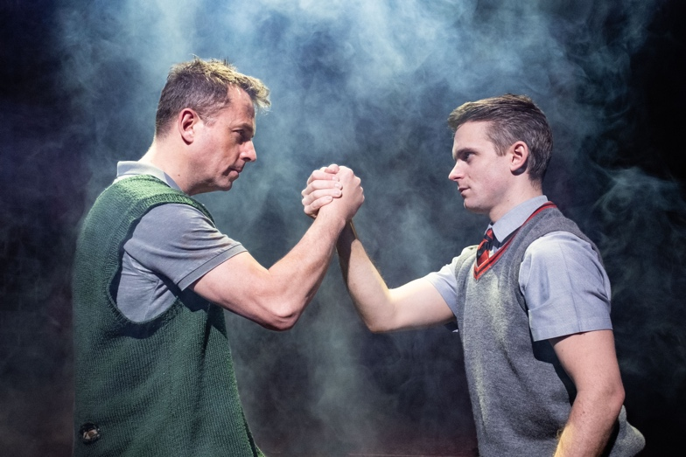

*(Clockwise from Top Left: Blood Brothers (credit Jack Merriman), Martin Shaw in A Man For All Seasons, Dear Evan Hansen (credit Marc brenner) and The Rocky Horror Show)*

The Everyman Theatre, Cheltenham, has launched 2025 with the release of its new season brochure, packed with an impressive lineup of productions that promise to provide world-class entertainment to audiences in Gloucestershire. The season features a dynamic mix of West End drama, thrillers, Broadway musicals, comedy, ballet and dance, with something for everyone.

**Drama and Thrillers**

The Everyman Theatre kicks off a cold 2025 season by taking us back to a sizzling **Summer 1954** *(3rd – 8th February),* a double bill of Terence Rattigan’s *Table Number Seven* and *The Browning Version*, starring a stellar ensemble cast including **Dame Sian Phillips** and **Nathaniel Parker.**

**Martin Shaw** stars as Sir Thomas More in **A Man For All Seasons** *(11th – 15th February),* The gripping tale of integrity versus power, set during the tumultuous reign of Henry VIII, remains as timely and compelling as ever.

Prepare for spine-tingling West End thrills with **Ghost Stories** *(4th – 8th March)*, while Paula Hawkins’ bestseller **The Girl on The Train** *(25th – 29th March*) takes to the stage,starring novelist and podcaster **Giovanna Fletcher**, promising edge-of-your-seat suspense.

**Musicals**

Back by popular demand, the powerful musical **Blood Brothers** will make a highly anticipated return to Cheltenham this October (14th – 18th). This legendary tale of love, family, and fate has captivated audiences at the Everyman for years, frequently selling out.

Rock spectacle **Bat Out of Hell** *(31st March – 5th April)* will showcase the iconic and high-octane music of Jim Steinman and Meat Loaf, while Tony Award-winning musical **Dear Evan Hansen** (6th – 10th May) will make its way to Cheltenham as part of its first-ever UK tour, bringing its heart-rending story and iconic songs such as ‘You Will Be Found’ and ‘Waving Through A Window’ to local audiences.

Fans of nostalgia can look forward to **Cruel Intentions: The ‘90s Musical** *(11th-15th March)* which is packed with ‘90s pop classics, while local talent will shine as *Cheltenham Operatic and Dramatic Society* presents **Roald Dahl’s Charlie and the Chocolate Factory** *(15th – 19th April),* while fans of timeless musical theatre can look forward to *The Cotswold Savoyards*’ production of **Guys and Dolls** *(28th October – 1st November).*

Adding to the stellar lineup is the cult classic **The Rocky Horror Show** *(17th – 22nd February)*, offering audiences an astounding night of risqué fun and unforgettable songs, including *Time Warp* and *Sweet Transvestite.*

**Comedy**

The Everyman will welcome a host of comedians this year, including the newly announced **Alan Davies + Support** *(23rd March).* Alan is known for his sharp wit, observational storytelling, and his appearances on *QI* and *Taskmaster*. The **Cheltenham XL Comedy Club** also returns for 2025 with headliners **Babatunde Aleshe** *(17th January),* **Phil Wang** *(9th March),* and **Seann Walsh** *(25th May).*

For those seeking nostalgia, **Friends! The Parody Musical** *(6th – 11th October),* will deliver a hilarious and affectionate tribute to the iconic TV series. Packed with gags and the beloved quirks and quotes of Ross, Rachel, Monica, Chandler, Joey, and Phoebe, this musical will delight die-hard *Friends* fans and newcomers alike.

**Ballet and Dance**

Matthew Bourne’s New Adventure company will also launch its 2025 tour of **The Midnight Bell** in Cheltenham *(15th – 17th May)*. Set in 1930s London, this haunting dance theatre piece reveals tales of love, longing, and betrayal among lonely hearts in Soho’s pubs and foggy streets.

The Everyman Theatre’s 2025 brochure is bursting with entertainment for all ages. To explore the full lineup you can pick up a copy directly from the theatre’s foyer on Regent Street or read the brochure online at <https://issuu.com/everymanchelt/docs/che_bro_jan25_digital?fr=sYTQxMTY1MjgyMDA>

Don’t miss your chance to see these exciting productions on your doorstep this year.

**ENDS.**

**Editor Notes**

For media requests and interviews please contact [lauren@encorepr.co.uk](mailto:lauren@encorepr.co.uk)

**Images available to download from** [**https://www.dropbox.com/scl/fo/yxqk12t341a1vt7c97ax7/h?rlkey=1yvhvzyqk3regf97ekur28yqf&st=nhjohnaz&dl=0**](https://www.dropbox.com/scl/fo/yxqk12t341a1vt7c97ax7/h?rlkey=1yvhvzyqk3regf97ekur28yqf&st=nhjohnaz&dl=0)



**About Everyman Theatre, Cheltenham**

The Everyman Theatre is Gloucestershire’s leading live entertainment venue, presenting a wide range of productions year-round, including ballet, opera, drama, dance, comedy, live music and a traditional annual pantomime. Opened in 1891, The Everyman Theatre is a Victorian masterpiece, with its magnificent main auditorium designed by esteemed architect Frank Matcham.

A registered charity, The Everyman Theatre is proud to offer a leading education, community and outreach programme, which includes a Summer School, Youth Theatre and Community Choir, offering people of all ages the opportunity to engage with the arts.

**Instagram: @everymanchelt**

**Facebook: everymanchelt**

**Tik Tok: @everymanchelt**