**Gloucestershire’s homegrown pantomime goes ‘Willy Wonker’ for charity!**

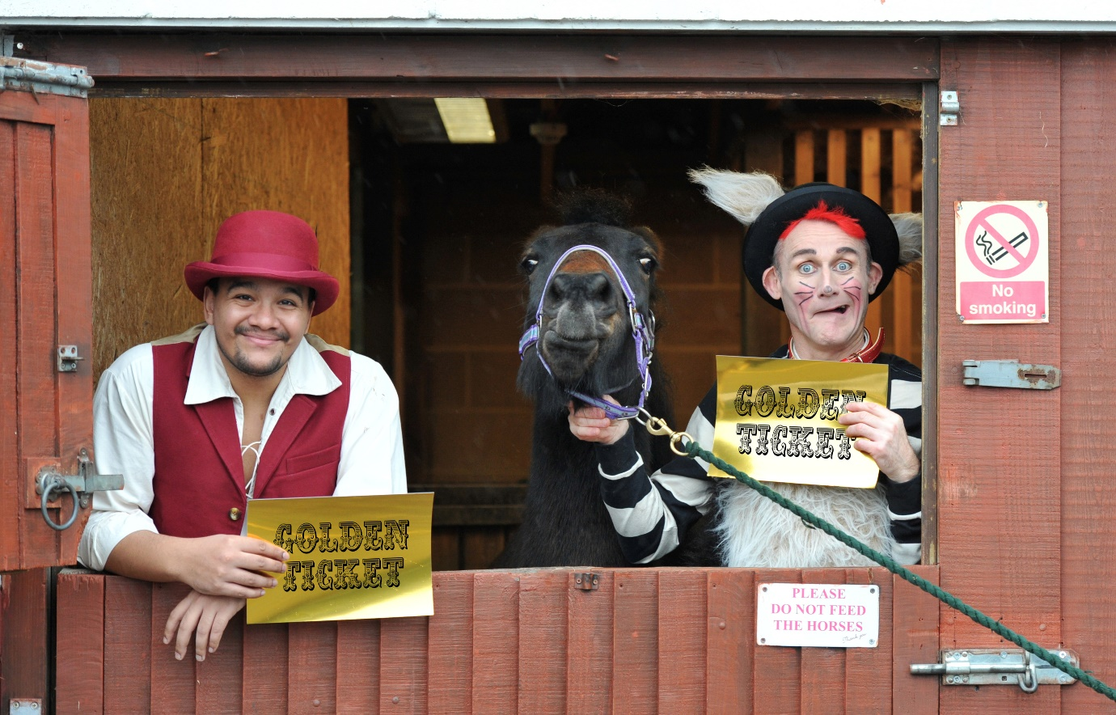

*Dick Whittington & His Cat Tweedy at St James City Farm & Riding School*

Cast members from **The Everyman Theatre’s** new pantomime, **Dick Whittington and His Cat Tweedy**, delivered the much-prized golden tickets to charitable partners St James City Farm & Riding School this week and were joined by Scrubditch Care Farm, to unite the pantomime’s two charitable partners in the run up to the launch of this year’s new festive show.

With tickets selling fast for the pantomime and with many performances now SOLD-OUT, the charitable partners and the Everyman Theatre have created a rare Golden Ticket opportunity with a hand-picked selection of prime seats.

The Golden Tickets are the last chance to see these sold-out performances of Dick Whittington and His Cat Tweedy and gives everyone the chance to help vulnerable children and adults throughout Gloucestershire by supporting the two charities.

**Mark Goucher**, CEO of The Everyman Theatre, said: “*This year we are supporting two Gloucestershire charities whose combined work covers much of the county. Here at the theatre, we are passionate about the work of both charities and hugely supportive of the work they undertake. Both organisations run fantastic community-based programmes and by offering a limited number of exclusive Golden Tickets, it’s a great way to raise additional money for the pantomime charities this year. Our target is £20,000 over the whole season and everyone visiting the pantomime this Christmas will have the opportunity to take part and support charitable giving across Gloucestershire.”*

Golden Tickets are available for selected performances on the 20th – 26thDecember 2022. With each ticket purchased, £68 will be donated to support the work of the Scrubditch Care Farm in North Cerney and St James City Farm and Riding School in Tredworth. For information on how to purchase your Golden Ticket and support the work of these amazing organisations, visit [**everymantheatre.org.uk**](https://www.everymantheatre.org.uk) or call the box office on **01242 572573**.

**ENDS**

**Editors Notes**

For further information, quotes or interviews, please contact [melanie.jones@encorepr.co.uk](mailto:melanie.jones@encorepr.co.uk)

For high res images click here - <https://www.dropbox.com/scl/fo/ph5fygzb77auoz4tjnsrr/h?dl=0&rlkey=b63qukr7pmy07zar8g16qauna>

**About The Everyman Theatre**

The Everyman Theatre is Gloucestershire’s leading live entertainment venue, presenting a wide range of productions year-round, including ballet, opera, drama, dance, comedy, live music and a traditional annual pantomime. Opened in 1891, The Everyman Theatre is a Victorian masterpiece,

with its magnificent, recently restored, main auditorium designed by esteemed architect Frank Matcham.

A registered charity, The Everyman Theatre is proud to offer a leading education, community and outreach programme, which includes a Summer School, Youth Theatre and Community Choir, offering people of all ages the opportunity to engage with the arts.

**About Scrubditch Care Farm – Pantomime Charity**

​

Set in a beautiful location with stunning views in open countryside, Scrubditch Care Farm provides meaningful farm-based activities for adults and young people with learning difficulties, challenging behaviour, or mental health problems.

Students perform a variety of activities including working with animals, growing vegetables, fruit and flowers, cooking and learning basic woodworking skills. The Farm also runs weekly ‘feel good farming’ sessions for people living with dementia or struggling with mental health and wellbeing.

Scrubditch Care Farm is a small registered charity, and the site is a secure and safe environment where students feel at home.

**About St James City Farm & Riding School – Pantomime Charity**

St James City Farm & Riding School lies at the heart of one of the most deprived areas of Gloucestershire and offers a taste of the countryside to those who need it most as well as being a wonderful place to visit for families.

The City Farm & Riding School offers hands on practical farm experience and gives access to opportunities; acting as a gateway, building knowledge, experience and aspirations so city people can have fun, learn and benefit from interaction with animals and nature.  
  
Run by ‘The Friendship Cafe’ - a registered local, charity, run mainly by volunteers - the farm provides a safe and welcoming space for volunteers of all ages and backgrounds.

**Investec – Pantomime Sponsor**

Investec, which has had an office in Cheltenham for over 40 years, provides bespoke and integrated financial planning and investment services for local clients. It has a strong corporate social responsibility ethos and is keenly aware of its broader responsibility to society, seeking to make a positive impact by focusing on initiatives that support local communities.

As one of the UK’s leading wealth management firms, we are trusted with managing over £44.3 billion (as at September 2021) of our clients’ money. Our wealth and banking teams work hard at providing Out of the Ordinary levels of service to our clients and with an investment heritage dating back to 1827, we’re built for the long term.

With investment your capital is at risk.

Investec Wealth & Investment Limited is authorised and regulated by the Financial Conduct Authority and is a member of the London Stock Exchange and the Investec Group.

Investec Wealth & Investment Limited is registered in England.

Registered No. 2122340. Registered Office: 30 Gresham Street. London. EC2V 7QN